4.Create a simple cloud software application for Library book reservation system for SIMATS library using any Cloud Service Provider to demonstrate SaaS include the necessary fields such as Title of the book, author, publications, Year, edition, no of copies, Rack no, status (taken/returned) etc.

Step 1:Create the customer details

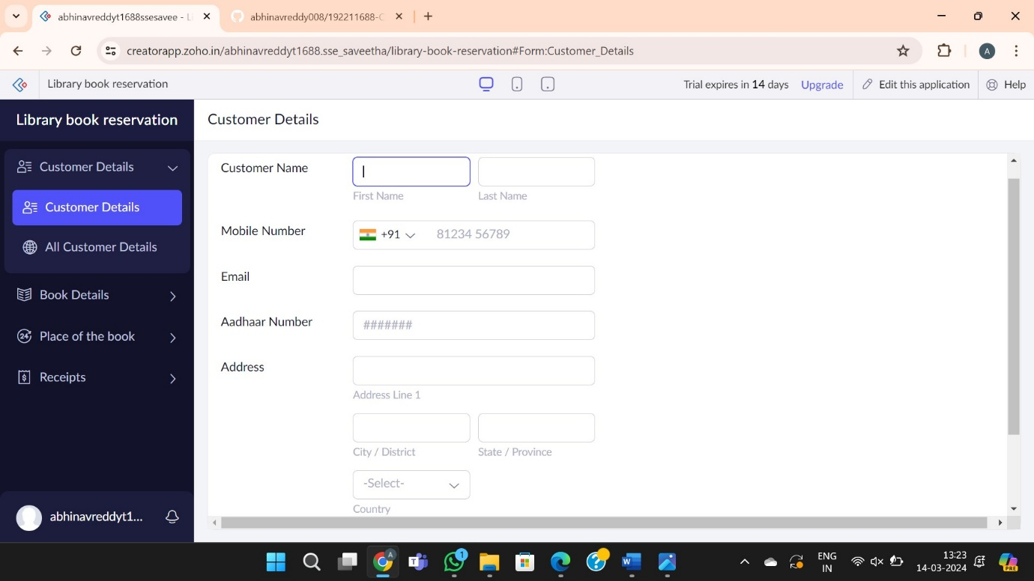

Step 2: create the book details

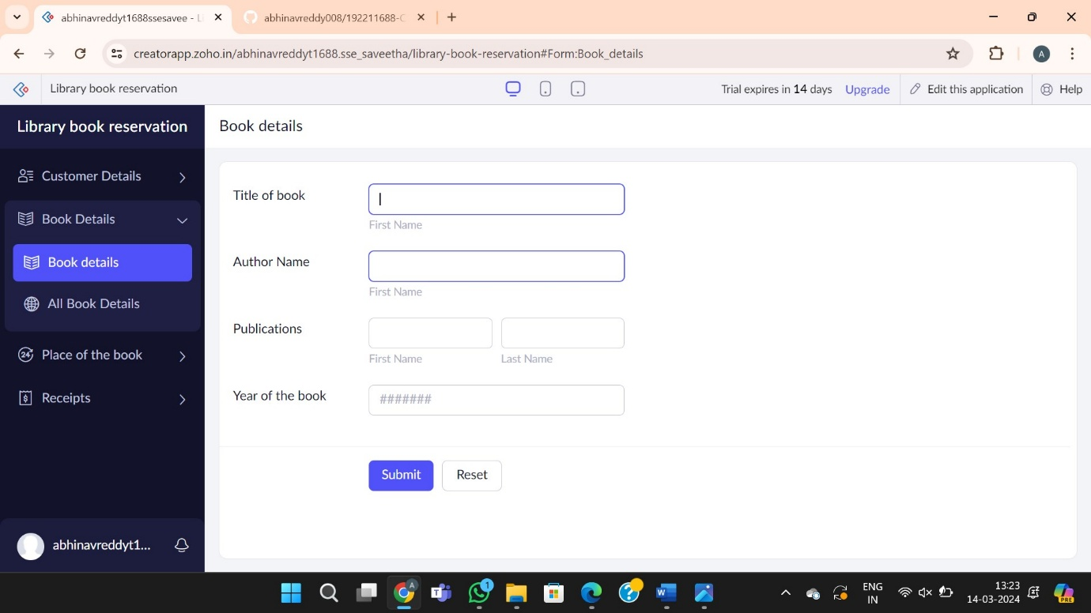

Step 3: Create the place of the book



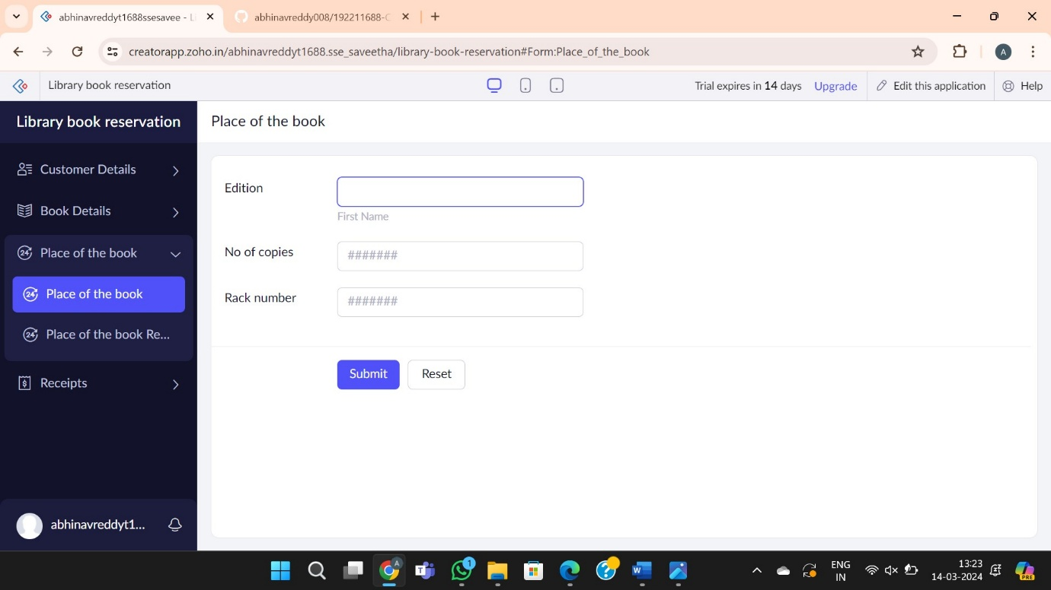

Step 4: Create the receipt

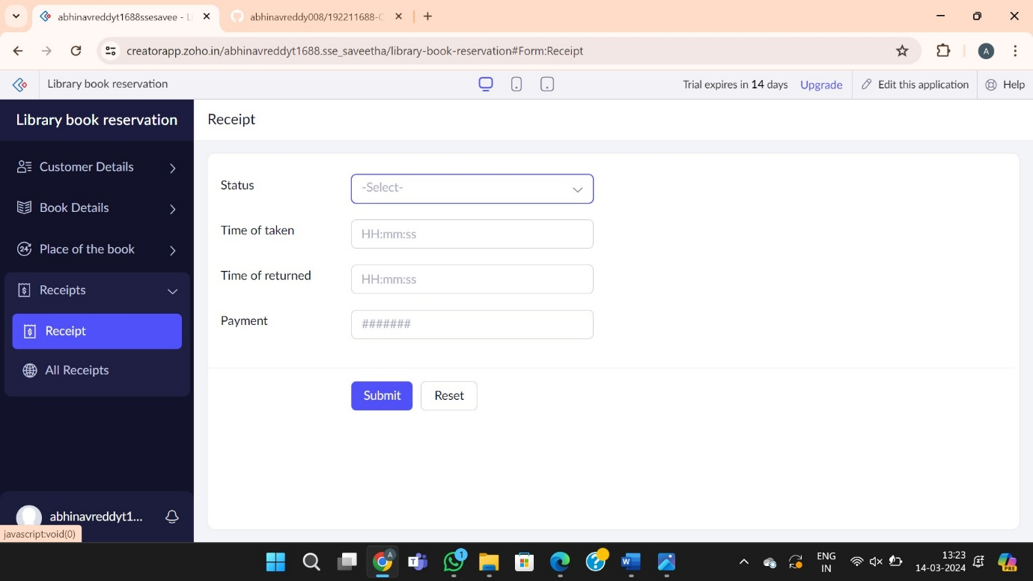

Step 5: Report forms of library booking system



